HAM RADIO IN A BLOCK OF FLATS

ANTENNAS NOT ALLOWED That is unfortunately a very prominent part of the Covenant one usually has to sign when moving into a flat. It can however with some diplomacy, be modified into no VISIBLE antennas allowed. The major problem still remains of Electro Magnetic Compatibility, and that means RF must be confined to its proper place, both on reception and transmission. You are top of the list when anyone’s TV or computer plays up.

Remember the fundamentals. Radiation depends on RF current flow in a wire. 2 terminals are needed for current to flow, eg the + and - of a battery, the two wire feed of a centre fed dipole, or the vertical wire AND the radials of a vertical antenna. – break one of them and current cannot flow and the wire cannot radiate. Breaking one terminal can be easily done with an RF choke, usually made up of a few turns on a ferrite ring or rod.

The second fundamental is the Reciprocity theorem, which basically states that radiation characteristics are identical on transmission and reception. This means that the actions you take to eliminate RF in, as interference, are also helping to ensure the EMC of RF out from your transmitter.

In practice the two requirements are, filter every lead that enters the shack particularly the mains, and bond all earth points to one place. My flat is on the top at a height of 20 metres. This may be good for antennas but at this height there is no earth and any thought of “earthing” something to stop it radiating is quite impossible.

THE MAINS LEAD, This must have all 3 wires including the earth lead, fully filtered at the point of entry to the shack . ALL equipment including rigs and linears, test gear, computers, printers and soldering irons, must be plugged in to that filtered supply. It goes without saying that all equipment mains plug earth leads must be connected for safety reasons. The Protective Multiple Earth system used on the mains supply these days also dictates that no other earth shall be used.

I have adopted a shack layout where all the 13 amp plugs are mounted on a board on the floor at the back of the bench. There is the advantage that the “spaghetti” associated with mains leads is out of sight under the bench. Every single mains lead in the shack is plugged into this board, the feed to which goes through the three wire mains filter to a wall socket via a single 13 amp plug. I am not aware of regulations limiting the number of plugs, which can be connected on a 13 amp extension lead. Common sense would indicate a fuse rating in each plug commensurate with the expected load. My total shack load with 400 Watts continuous RF power from a solid state linear, is 1,840 watts - 8 amps at 230volts, so no plug, even the single mains feed, is anywhere near its maximum ratings. Testing for conformity to IEE regulations is carried out with no equipment plugged into mains wall sockets, and the shack via its single 13 amp plug would therefore not be included in the test. I have no reason to think that the shack would not comply with regulations, which place great emphasis on earthing and bonding, which is the object of the exercise. Equipment after a 13 amp plug is a distinctly grey area in the regulations.

The rear half of the operating bench is covered with metal sheet, and this is the “Shack Earth” . All equipment is bonded to it with short lengths of metal strip. The outer of the coaxial antenna feeds are connected to this sheet at the point of entry to the shack, and the metal case of the mains filter, which is connected to the output side of the mains earth is bolted to it also. PHOTO 1 illustrates the mains and antenna inputs, with the plastic cover removed from the filter. The mains filter is a Belling Lee 3 pole mains filter REF 1 designed to totally isolate all three of the mains leads, and is the only mains feed to every single item in the shack.

COMPUTER It goes without saying that all computer leads MUST be screened. The shack computer should be a metal cased desktop, not a laptop and should be mounted on the metal sheet on the bench with a short copper strap to the case to ensure that it is earthed. Computers are full of noise generating devices – clock oscillators and high speed square wave generators etc. Computer design makes very little attempt to contain this radiation. A screening box with no filters on the connecting leads is useless. 3 wire filters are available REF.2 that plug in the mains lead, and should be used. All other connections to the computer must have RF chokes on them, at the computer end. Turns on a ferrite ring are preferable but if moulded connectors preclude this, turns on a ferrite rod may be used. Clip on ferrites are only effective at VHF and above, although sometimes it is possible to use the largest clip on and wind as many turns on it that will allow it to clip shut. The single filtered mains connection is particularly important with computer peripherals, such as a printer, which may be mounted on another table with a different mains plug. The screening of the printer lead from the computer will bypass all your careful precautions to RF isolate the mains earth. If you have to have the printer on another table, the answer, as I do, is to use a network printer with a WI FI connection.

THE TELEPHONE LINE This is in theory a balanced pair, and should not pick up RF from the transmitter. In practice as with so many “balanced” lines including aerial feeders they are not balanced, and common mode currents from the transmission will get into the phones. This can be eliminated by winding the line onto a ferrite ring at the main entry wall socket, this will help prevent problems on other phones in the block. The small size of the telephone plug does allow use of a ferrite ring.

DSL currents for internet connection on the phone line are balanced and will not be affected by the common mode ferrite rings. The DSL filters used for internet working are in fact useful low pass filters on the connection to the phone, and TX interference that is not common mode on any particular phone, can often be reduced by adding a further DSL filter to that phone line, using ONLY the phone connections and leaving the DSL plug or socket strictly alone. This can only be done on a phone that has already passed through the main DSL filter. DSL filters vary in performance and it is worth trying different makes in difficult cases. I have found the BT filters the best so far.

ANTENNAS. It is vital to remember that antennas like any other electronic circuit, require two connections. Either balanced pair, or single connection and earth. Any attempt to avoid the use of radials, with a loaded whip, results in using the mains as the “other half” of the antenna, which is totally disastrous, and results in heavy interference on reception, and radiation into the many electronic devices in the building. At 20 metres high, I have to emphasise that no RF earth is available and loaded whips etc require quarter wave radials. Once it seemed a good idea to drop a nicely hidden wire down a plastic drain pipe, some 20 metres long. This seemed an ideal hidden ¼ wave “other half” or radial on an 80 metre loaded whip. The pipe of course passed by a number of flats, probably past the back of TV sets, and the high noise level on receive, and remembering that reciprocity theorem, the risk of RF getting where it shouldn’t on TX, made this quite impossible. I dare not even try a test transmission.
During my 10 years at this QTH I have tried all imaginable antennas and the double trapped dipoles have proved to be the best. One particular system involved the feedpoint being some 2 metres above my head, and although there appeared to be no ill effects, it was thought to be not a good idea. With the present system no wire is nearer than 7 metres to the operating point, which has a greatly reduced RF field.

Fortunately I have access to a flat roof, some 20 x 10 metres, and wire antennas, albeit shorter than optimum, are possible so long as they cannot be seen from below. The result of this is that the antennas are nicely up at 20 metres, but cannot be very high above the roof.. I have been able to use the lift house in the centre of the flat roof, to provide a 6ft. high mounting for the feed point box, which includes a choke balun. Usefully placed low chimneys provide mounting points for the ends of the antennas.
I have found 1.5 mm enamelled single wire to be best for antennas, and it is virtually invisible from below.

Fig 1 illustrates the layout of the antennas, which are trap dipoles. The use of multi band trap dipoles merits an article on that subject alone. Suffice it to say in this case, I have used two trap dipoles fed in parallel from the same feed point. This is possible providing the feed point impedance of each antenna is high at the frequencies of the other antenna, and it is possible to mount the ends of the smaller antenna “bow tie” fashion away from the main antenna. In this case we have an 80 metre dipole trapped for 60 and 40 metres, in parallel with a 20 metre dipole trapped for 10 metres. This gives good matching without an ATU on 80,60,40,20, and 10 metres. Fig 2 shows a VNA scan of the SWR at the shack feed point.

THE TRAP DIPOLE is the only antenna I have found, to comply with my requirements. The traps reduce the length enough to fit the antenna into the limited space available, and allow use of a balanced feed point plus baluns to provide a matched coaxial feed into the shack. I have written an article on the design of traps REF3.
Traditionally, traps are decried as lossy devices. A well designed trap will be made from extremely low loss materials. Silver plated wire, PTFE insulation and a Polypropylene coil former, all easily and cheaply available. The trap at resonance will have a Q approaching 200 and a resonant impedance of at least 150,000Ω. Losses at resonance are negligible, bearing in mind that the end impedance of a dipole in practice is some 2000Ω and we will be using an insulator (the trap) with an impedance of some 150,000Ω. Practical tests have failed to show any rise in temperature of a well designed 7 Mhz. trap on a 3.7 Mhz. dipole handling 400 watts of continuous power at 7Mhz. Similarly the same trap operating off resonance as a load with 400 watts of 3.7 Mhz power still remains cold. Some Canadian friends with their multi kilowatt rigs are at the moment trying to burn out some of my traps, so far without success.

INTERFERENCE. I haven’t lit up any “unswitched on” fluorescent lights yet, although the flat below did experience uncommanded illumination of an automatic standard lamp. That took a strategic ferrite ring, quite a few Gin & Tonics and considerable diplomacy to overcome.

I have found that the best way to keep RF where it belongs is to use antennas with a balanced feed point and a balun to convert to unbalanced coax cable. I have written about “Controlled Feeder Radiation” which can be quite useful when the feeder is deliberately made to radiate as part of the antenna.. In this case we require no feeder radiation.
The other problem I dread is of course, the installation by someone in the block of a Powerline Ethernet adaptor system. I have prevented it from coming in on my mains feed, but will it radiate straight into my antennas and bypass all the isolation? Or worse, will my radiation wipe it out!! Remember the Buck stops here.

PURITY OF SIGNAL . Modern Rigs have to meet stringent standards, and a low pass filter is unnecessary, but if there are any doubts, particularly if the rig has been modified for 5 Mhz. – use a low pass filter. Similarly home built rigs should be treated to a session with a spectrum analyser. Adequate filtering is a part of home construction that does tend to be neglected.

Following slavishly these fundamentals has enabled me to operate at the full legal 400 watts on the top floor of a 20 metre high block of flats, and keep the peace with the neighbours. Again that reciprocity - it was quite a revelation when I first commissioned the system to see my S7 noise level on 80m reduced to S2 with resonant half wave antennas connected, and the computer running. Another useful effect is the peace of mind from the ability to easily isolate the shack from lightning. Rather important when you see that thunderstorm a few miles away, slamming lightning into the sea, and coming straight for you. Just remove the antenna plugs, the dsl telephone line, and that single 13 amp mains plug, and the shack is safe – not perhaps from a direct hit but at least protected from nearby strikes.

REF.1 Belling Lee Mains Filter type SF4240 16 AMP Available Farnell
REF. 2 Roxburgh PMF6 in line filter Available Farnell

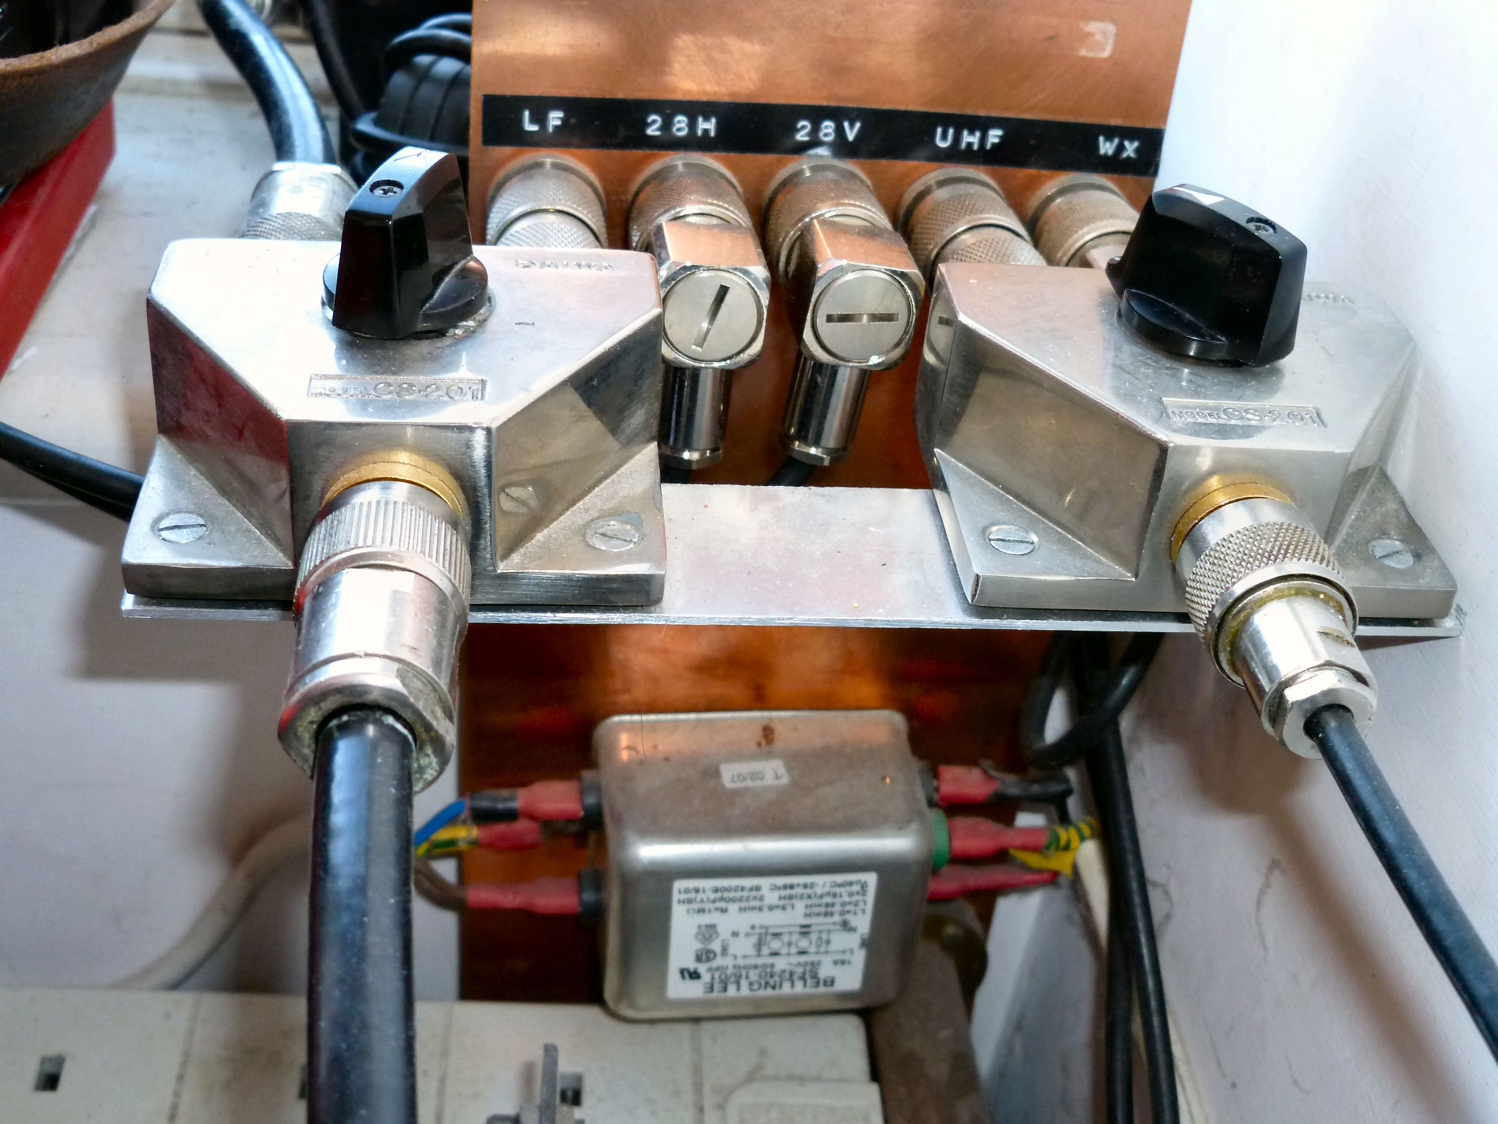

Photo 1 This shows the entry of the mains through the metal cased filter, with its plastic cover removed, and the entry of the coaxial antenna feeders. The foreground switches connect to artificial loads. The vertical copper sheet is bent at right angles and bolted to the horizontal shack earth sheet.

