TRAP DIPOLES

LOSSES. Traditionally, traps have been considered to be lossy devices, and are therefore to be avoided. ATUs are also lossy devices and the correct use of traps will eliminate the use of an ATU.

It is possible to cheaply make a high efficiency trap from Silver plated wire, PTFE insulation and a Polypropylene former, all extremely low loss materials. The trap at resonance will have a Q approaching 200 and an impedance of at least 150KΩ. Losses at resonance are negligible, bearing in mind that the end impedance of a dipole is in the region of 3000Ω and we will be using an insulator (the trap) with an impedance of some 150,000Ω. Practical tests have failed to show any rise in temperature of a well designed 7 Mhz trap on a 3.7 Mhz dipole, handling 400 watts of continuous power at 7Mhz. Similarly on the same antenna, the same trap operating off resonance as a load with 400 watts of 3.7 Mhz power still remains cold.

A correctly designed trap dipole will have each frequency section of the antenna isolated from the others. Consider a 4 trap dipole for 20, 40 & 80. On 20 the inner 20 meter traps isolate the rest of the antenna. The 40 meter traps and the rest of the antenna do not exist to 20 meter RF. Similarly on 40, the 40 meter traps isolate the outer sections and the 20 meter traps are used as loads, and on 80 no traps are on resonance, they are all used as loads.

It should be possible for example to resonate the outer ends of an 80/40 meter trap dipole to the wanted 80 meter frequency, without affecting the 40 meter resonance. This will only happen if the traps are on frequency. If they are not, and have to be pulled in by altering the resonant 40 meter dipole length the whole antenna becomes part of the 40 meter resonance and isolation will not be achieved. This has been proved in practice many times, and the Eznec antenna design program will confirm.

This isolation feature relates to the true trap dipole. Many commercial designs,
sometimes with an essential, resonant 75 ohm flat twin feeder, deliberately use the traps as loads, providing multiple resonances. Any trap dipole will produce secondary resonances, which can be guided into useful bands by careful trap design.

DESIGN CRITERIA. Apart from low loss construction, the main design factor is L/C ratio. High L and Low C traps can reduce the overall length of a trap dipole by as much as 33%, which may be desirable in practical circumstances, but the penalty will be reduced bandwidth, particularly on the lowest frequency band of the antenna where the traps are operating as loads. Low L and High C traps will only reduce the overall length by some 17% with little bandwidth reduction. The problem however is providing suitable high value, high voltage, low loss capacitors.

The problem of suitable capacitors has been solved by the W8NX designs of traps made from coaxial cable. Nowadays, the construction is made easy with computer design programs and easily available low loss materials.

It is largely unknown that a trap wound with coax cable (coax traps from now on) can be connected in three different ways, with 3 different L/C ratios.

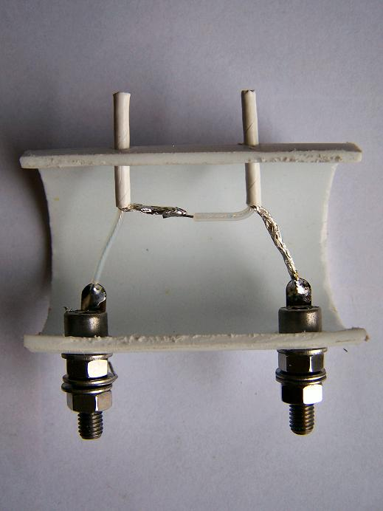

PHOTO.1 Series connection of the inner and outer to provide high inductance and low capacitance.

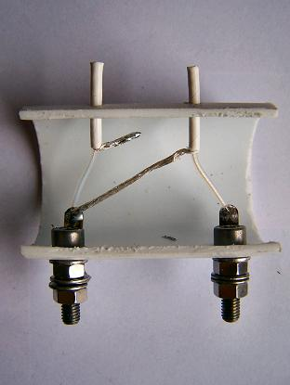

PHOTO.2 Parallel connection, with the inner of the coax as the inductance, to provide low inductance and high capacitance.

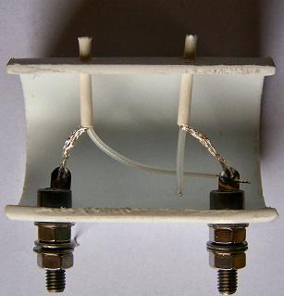

PHOTO.3 Parallel connection with the outer of the coax as the inductance, to provide even lower inductance and higher capacitance.

Surprisingly the same coax trap will resonate on the same frequency whichever way it is connected. Typical figures for a trap wound with 50Ω coax for 7.093Mhz. are,

Series connection; (photo1) inductance 17.5μH, capacitance 28.8 pf .
Parallel Inner connection, (photo2) inductance 4.025μH capacitance 125.1 pf.
Parallel Outer connection, (photo3) inductance 3.630μH capacitance 138.7 pf.

The outer connection for the inductance would normally be used to give maximum power handling capability, but the different L/C ratio of the inner connection may be useful to bring a secondary antenna resonance into a frequency band.

TABLE 2 lists the figures for L and C of the three connections, which may be used in the loads section of the Eznec antenna design program to show the effect of the parallel and series connection on the overall length of the antenna, the consequent bandwidth change, and the secondary resonances.

Use of the parallel or series connection may well depend on the length available. For example, a 3.7 Mhz dipole with coax traps for 5.4 Mhz and 7.1 Mhz with parallel (Low L) connections will have an overall length of 33.6 meters, with reasonable bandwidth on each band. Whereas the same traps series connected (High L) will result in an overall length of 26.8 meters. but with reduced bandwidth particularly on 3.6 Mhz. It may therefore be preferable if the bandwidth is important, to use the low L parallel connection, and bend the ends of the antenna to fit the space available.

MEASUREMENT OF TRAP RESONANCE. There are many ways of measuring the resonant frequency of a trap, and experience has shown that they will all yield different results. The obvious method of measurement is to place the trap in series with the output of a signal generator and the input of an RF voltmeter, tuning for minimum signal. The problem here is the length of connecting leads, which are all in the circuit, and add an inductive component. The impedance presented at the input and the output of the trap is also incorrect; the 50Ω output impedance of the signal generator, and the probable capacitive input impedance of the RF voltmeter is certainly not that of the end of a dipole where the trap will be operating,

The only method that yields accurate and repeatable results is a loosely coupled Grid Dip Oscillator (GDO) with a frequency counter providing an accurate frequency read out. In this method the trap has no external connections and behaves as it would in practice, connected to the high impedance end of a resonant dipole.

TRAP CONSTRUCTION. The coaxial cable used is RG316 or RG188 and all dimensions and parameters given, apply only to this cable. RG316 and RG188 are PTFE insulated 2.7mm diameter 50Ω coax with silver plated wire.( The quoted 50Ω impedance is nominal. Measured value of the sample used by the writer was 51Ω) Surplus price is 50p per meter (from WWW.WHWESTLAKE.CO.UK. Tel 01409253458). Only 1.5 meters is required for a 7 Mhz trap so even at new price it is hardly expensive. The former is standard B&Q 40 mm polypropylene drainpipe (usually measuring 41mm). Connection terminals should use tin plated brass solder tags, and washers to spread the load on the polypropylene former, with 5mm brass or stainless steel bolts and nuts.

A practice has arisen whereby the aerial wire is fed through an adjacent hole in the trap former and then on to the terminals. This of course removes the strain on the terminals, but the writer is not happy with this as the extra inductance of the loop of wire becomes part of the trap and spoils the required co relationship between design frequency and actual frequency in practice of the antenna.
It has been proved in practice that 5mm (or 2BA) brass or stainless bolts are perfectly capable of taking the strain directly of these lightweight traps.

There are many design programs for coax trap dimensions, some give the parameters for series connection and some give parallel. None of them state which.

TABLE 1. gives the parameters for trap construction using RG316 for all bands from 80 to 10 meters. The table gives hole centres for the winding, but due allowance should be made for part turns. The winding width should be increased by 4 cms. to give the cut length of the former including the terminals.

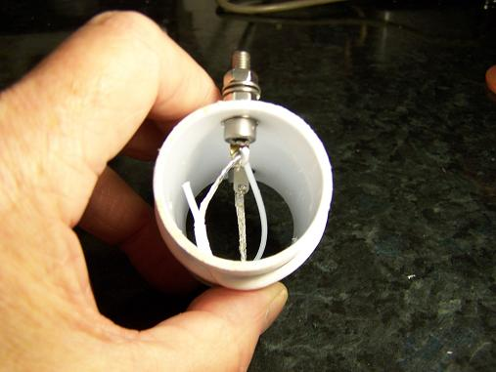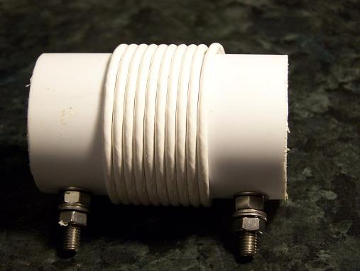
PHOTO 4 & PHOTO 5 show a complete 40 meter trap.

The figures are accurate and if the dimensions, particularly number of turns, and part turns, are closely followed, the frequency will be within a few Khz of design. The width of the winding assumes close turns. The 3 mm drill used to drill the holes for the coax. should be angled to elongate the hole in the direction of the winding to make the right angle turn for the coax through the former, less acute. Table 1 gives the length of coax required, but to allow for winding tolerances, it is best to temporarily wind the coil and insert the ends through the holes to find the exact length required. Then cut the coax and "tail" and tin the ends for the outer and inner connections before finally winding (2.5 cms tails both ends for series and 2.5cms and 5cms for parallel). Correct connections as shown in the photos are vital. The parallel outer connection does not connect the inner of the coax at one end, but remember to leave 1 cm. of PTFE covered inner wire. This is one side of a capacitor working at very high voltage at high power. Similarly the parallel inner connection does not connect the outer of the coax at one end.

IDEALLY. the traps should be made with an extra cm on the length of winding and then resonated by adjustment of the turns spacing at the ends, using a GDO and Freq Counter. If no test instruments are available, accurate work may well be sufficient. The total weight of a 40 meter trap made in this way, is 50 grams or 1 ¾ oz. and it will handle 400 W and probably more, but the writer is not able to check this.
Weather proofing is accomplished by liberal doses of UHU or similar adhesive on all the coax ends and a spray of clear lacquer to hold the coil turns in place. A dash of Waxoil on the bolts is always a good idea to enable the nuts to be unscrewed after long service.
The type of antenna wire used is a personal preference, but the writer has found hard drawn 16swg enamel to be the least trouble, particularly when making connection to trap terminals and baluns. In theory, although hard to measure, skin effect makes stranded wire subject to losses if corroded.

A trap dipole with parallel outer traps for 5.380 Mhz and 7.093 Mhz has the following measured frequency coverage.

Better than 2/1 SWR 3.629 – 3828 5361 – 5440 7031 - 7172

Centre freq. 3727 5400 7098

Secondary resonances 3/1 SWR tunable with rig auto ATU 14.2 22.0 31.0

Dimensions for the antenna are:

__________T5______T7____________B____________T7______T5____________
4.6m 2.2m 10m 10m 2.2m 4.6m

T5 = 5.380 Mhz trap
T7 = 7.093 Mhz trap
B = Balun to 50Ω coax. feeder

This antenna has been made to these dimensions many times locally and if strung up in the clear, always proved to be on frequency without adjustment.

FEED LINE FOR A TRAP DIPOLE Lots of controversy here, but as far as the writer is concerned, it has to be 50Ω coax AND A BALUN at the antenna.
This is not only purist professional principles, but the necessity to keep RF strictly in the place where it belongs when living on top of a block of flats as I do, where no aerials are allowed. The problems here are beyond the scope of this article, suffice it to say that a correctly designed trap dipole erected close (invisible from the ground) to the 20m high, wood and felt flat roof of the flats has allowed 400W on 80 & 40 and 200W on 60, with a matched feeder, no ATU, and peace with the neighbours.

Resulting from problems with the planners, regarding outside antennas, it has proved possible to run a trap dipole along the top of a garden fence at a height of 2 meters, with useful operating characteristics. A word of warning. At high power, very high RF voltages exist on trap terminals, and popularity with the neighbours will not be enhanced by burnt fingers.

TABLE 1

RG316 coax of 2.7mm diameter, and 41mm diameter former.
Width of winding is hole centres, but allow for part turns.
Cut length of former is winding width plus 4cms to allow for connecting terminals.
Length of coax should be cut 7.5cms longer

Freq Mhz. No. of Turns Coax Length cm Width of winding mm

5.380 12.75 176 38

7.093 10.15 139 30

10.120 7.54 104 20

14.223 5.72 79 16

21.275 4.16 57 10

24.912 3.68 51 8

28.698 3.3 45 7
TABLE 2

Gives the parameters for the three connection systems for the traps listed in Table 1.

Connections
. Parallel Series
Freq Impedance inner outer
Mhz Q KΩ μH pf μH pf μH pf

5.380 175 143 5.525 158.4 4.983 175.6 24.1 36.4

7.093 185 144 4.025 125.1 3.630 138.7 17.5 28.8

10.120 195 143 2.64 93.6 2.381 103.9 11.5 21.6

14.223 202 137 1.76 71.1 1.587 78.9 7.6 16.5

21.275 207 128 1.09 51.3 .983 56.9 4.6 12.1

24.912 208 123 0.89 45.9 .803 50.8 3.8 10.8

28.698 208 119 0.76 40.5 .685 44.9 3.2 9.7

